Ideation Phase
Brainstorm & Idea Prioritization Template
Date | 18 June 2026
Team ID | N/A
Project Name | Book-A-Doctor Healthcare Appointment Management System
Maximum Marks | 4 Marks

Brainstorm & Idea Prioritization Template
Brainstorming provides a collaborative environment for generating innovative healthcare solutions. This document captures the brainstorming, idea grouping and prioritization activities for the Book-A-Doctor project.

Step-1: Team Gathering, Collaboration and Select the Problem Statement
Problem Statement: Patients face difficulties in finding suitable doctors, booking appointments, managing medical records and receiving timely healthcare updates.
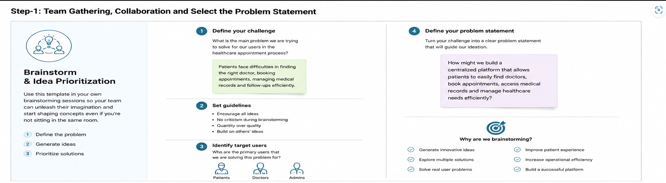

Step-2: Brainstorm, Idea Listing and Grouping
Patient Features: Doctor Search, Appointment Booking, Medical Reports, Notifications.
Doctor Features: Schedule Management, Prescriptions, Patient Records.
Admin Features: Doctor Approval, User Management, Analytics.
Advanced Features: Telemedicine, Payment Gateway, AI Recommendations.
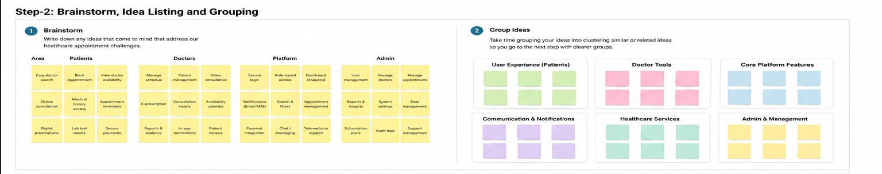

Step-3: Idea Prioritization
High Priority: Appointment Booking, Doctor Search, Medical Records, Notifications.
Medium Priority: Payments, Analytics, Doctor Reviews.
Future Enhancements: Telemedicine, AI Recommendation Engine.
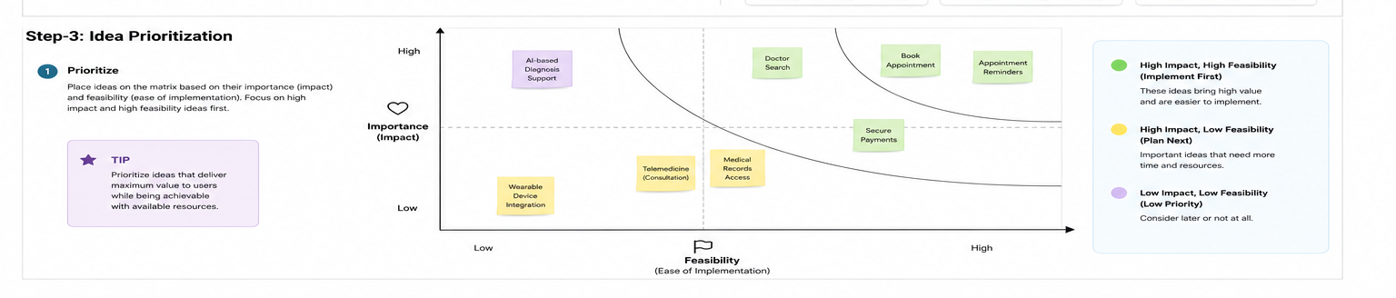

References
https://react.dev/
https://nodejs.org/
https://expressjs.com/
https://www.mongodb.com/docs/

